

## There are many different types of developers and the lines between distinguishing which one you are can be blurred. The more experienced and professional you become, the more types you will fit. Nowadays, different developers have similar if not the same skills needed to complete their role. However, there are also certain skills that will make a developer unable to do every developer job there is out there. For example, a mobile developer may know the same tools as a game developer but isn’t a game developer and would not be able to complete their job. This makes a huge difference in the types of developers, so below are some different types that you may come across.

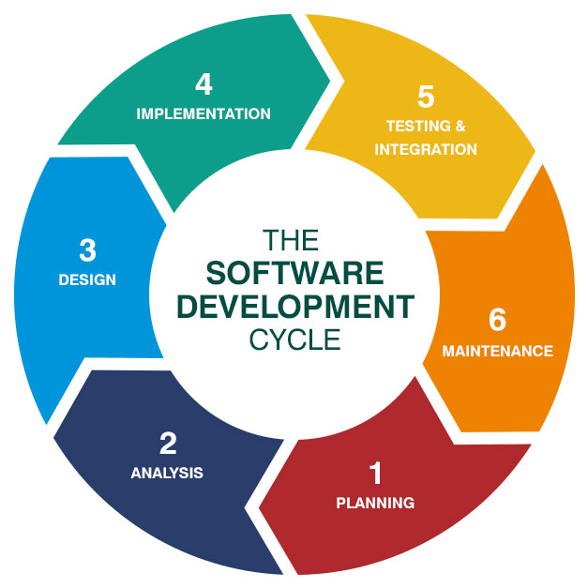

The software development life cycle (SDLC) is a process used by the software industry to design, develop and test high quality softwares. There are specific roles and responsibilities that can be found within each of these processes. For example – UX/UI typically works with the Planning/Analysis/Design and could be considered at the start of the SDLC while DevOps Engineer or Solutions Engineer could be considered at the end of the cycle once the code has been developed and now focus is on optimizing and improving or selling the product.

## **Types of Software Related Roles**

While most types of IT jobs require good technical understanding, different types of IT roles can be centered around management, development, hardware, analysis, etc. Let us look at some of these opportunities.

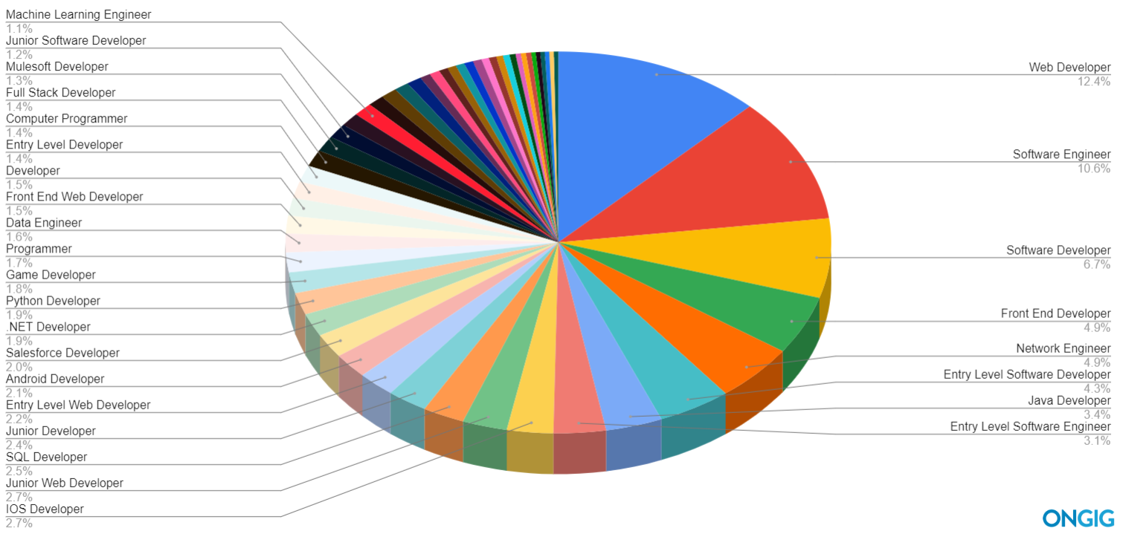

### **Programmers**

While developers are responsible for the overall design and scope of the product, programmers work on specific parts of the project. They are thus responsible to convert the product design into instructions that a computer can understand. Programmers usually work on several languages like Java, C#, PHP, SQL, JavaScript, etc. Being a programmer requires skills like problem-solving, analytical thinking, decision making, listening, and attention to detail. Programmers are involved in a specific part of the project — coding.

### 

### **Software Developer**

Software developers use their professional knowledge and skills to modify, write, and debug software for end-customer use. These professionals also document software and test applications for clients. Most software developers rely on their knowledge of ASP.net, Java, C#, and Python to do their jobs. A software developer's position requires a more holistic view of software than a coder or programmer would hold. Software developers are involved in the full cycle of product research, development, testing, and launch. Despite the breadth of their responsibilities, some software developers focus on a single niche, such as mobile application development or Internet of Things development.

* **Backend developers:** 
  + The backend developer specializes in design, implementation, functional logic and performance of a system that runs on a machine which are remote from the end-user. The back end of a website is made up from a server, application and a database and a back-end developer helps to build and maintain these components. By doing this they are enabling user-facing side of a website to exist. Their development skills are Java, C++, Ruby, Python, Scala and Go.
* **Frontend Developers** 
  + Frontend developers specialize in visual user interfaces, aesthetics and layouts. They work on creating web apps and websites as their codes run on web browsers and on the computer of the site user. Their role is solely focused on understanding human machine interaction and design more than theory. Their skills consist of design of user interface (UI), design of user experience (UX), CSS, JavaScript, HTML, UI Frameworks.
* **Full Stack Developers**
  + A full stack developer does both the front end and back end work for a site. They have the skills which are required to create a fully functioning website. Being a full stack developer will open up more opportunities for yourself as they work on both the server side and client side. The skills a full stack developer would consist of a combination of a front end and back end developer. A full stack developer should be able to set up Linux servers, write server-side APIs, client-side JavaScript powering an application and turn a design eye to CSS.
* **Mobile Developers** 
  + Mobile developers write codes for applications that run on mobile devices such as tablets and smartphones. Mobile developers only started to become popular after the boom of mobile devices in the early 2000s and the growth of the smartphone market. A mobile developer understands mobile operating systems such as iOS and android and the environment and frameworks used to create software on these systems. They have a variety of development skills, such as Java, Swift, Objective-C, Application Programming Interfaces, web development languages and cross platform mobile suites.
* **Game Developers** 
  + Being a game developer is very demanding and complicated. They specialize in writing games and have specific knowledge and skills in designing engaging interactive gaming experiences. Game developers use frameworks such as DirectX, OpenGL, Unity 3D, WebGL and programming languages such as C, C++ and Java. On mobile devices, Swift and Java are used for iOS and Android games.

### **Web Developer**

* + Web developers are programmers that work on building websites or web-based applications. These web applications are usually built using a client-server model. Web developers possess expertise in front-end languages like HTML, CSS, and, JavaScript and back-end technologies like PHP, Python, or Java. A good understanding of design, user interface, and wireframing is also necessary for web development. You may also need to learn about search engine optimization and some SEO tools. Developers are more involved with and have a greater understanding of the full project scope. **Web developers specialize in creating websites and web applications**

### **Software Engineer**

Software engineers are responsible for identifying issues and patterns to improve overall system quality. They can suggest improvement opportunities in various applications within a software company. These types of jobs in IT fielddemand in-depth technical knowledge, problem-solving ability, and hands-on experience in various programming languages. Software engineers focus on creating programs for operating systems. They apply engineering principles to the creation of computer programs and data management. Software engineers need to possess a solid knowledge of algorithms, languages, data structures, scalability, and best practices in systems engineering and web development. Generally, software engineers work with the same technology that developers use (including Java and C#), but they also incorporate analytics, testing, scaling, and communication into their work**.**

### **Applications Engineer**

Application engineers are usually hired to work closely with a sales team. Their primary job is to identify the challenges that customers are facing while using or applying their company’s solutions. They need to have strong knowledge about industry trends and the specific products they are focused on. Important skills you require are good communication and an ability to understand customer problems.

### **Quality Assurance Tester**

### The main job of a quality assurance tester is to ensure that the products released by the company meet the quality standards of the industry. This involves understanding the design of the product and ensuring it is error-free. QA testers are usually a part of product-based companies that require consistent maintenance and updates post-deployment. You also need to have clear communication so that you can document the test cases efficiently. A QA in a development team has to be a perfectionist with a strong focus on planning tests and test cases that should be detailed, structured, and well-knit.

### 

### 

### **Software Development Engineer In Test (SDET)**

### An SDET is someone who is involved in the project right from its planning stage and can help automate the testing process. Automation is a huge component of a good SDET’s job. A software development engineer in test is essentially a developer. Whereas, a QA Engineer is someone who has complete knowledge of various testing processes and methodologies.

### **Developer Operations (DevOps)**

DevOps is a software development strategy which bridges the gap between the developers and the IT staff. DevOps process involves a lot of development, testing and deployment technologies for developing automated CI/ CD pipelines. DevOps Engineer works with developers and the IT staff to oversee the code releases. They are either developers who get interested in deployment and network operations or sysadmins who have a passion for scripting and coding and move into the development side where they can improve the planning of test and deployment. DevOps developers are familiar with technologies which are able to build, deploy and integrate systems and manage back end software. To simplify the definition, a developer is someone who creates applications, an Ops, deploys and monitors the applications and a DevOps can create applications and deploy and monitor them. DevOps need experience in the following skills, Kubernetes, Docker, Apache Mesos, Jenkins e.t.c and the HashiCorp stack.

**Security Developer/Engineer**

Security developers specialize in creating systems, methods and procedures to test the security of software systems and fix security flaws. They use a variety of tools to complete their job such as scripting languages like Python and Ruby. They also use coding languages such as C and C++ to read and understand operating systems. The aim of their job is to ethically hack systems to discover their vulnerabilities. This type of developer often works as a “white-hat” ethical hacker and attempts to penetrate systems to discover vulnerabilities.

### **Business Analyst (BA)**

BA are responsible for translating business needs to requirements. They help businesses formulate business goals, and assist in defining the requirements during feasibility and foundations stages, sometimes even before the full development team is assembled. Assumptions must always be supported with analysis, so BAs should have a data-oriented mind. They create documentation, comparing it with existing policies and procedures/protocols to meet quality requirements. They also get the software development team together to establish the best strategy, based on what stakeholders need.

### 

### **Product Owner**

The Product Owner on a software development team possesses great knowledge of the project and user, understands the client’s perspective and needs, and strives to achieve the vision and requirements in a final product/service. They do everything to help the development team fulfill requirements in a fast-paced environment and generally focused on delivering the best value possible.

**User Experience Designer (UX)**

A user experience designer’s main task is to care about users’ experiences when interacting with the final product. This specialist’s work and decisions aren’t based on mere intuition, they are heavily researched and based on user studies. On the technical side, a UX designer should have some standards and procedures together with using many different tools for testing and solving user problems. The main focus of this specialist is set on product usability and functionality.

### **User Interface Designer (UI)**

UIs are constantly ensuring that a product’s every element is easily accessible, understandable and clear through graphic and branding design. Generally, UI is about connecting user interactions, visual design, and information architecture together. You need a UI designer when you want to build a custom user interface. Somebody who is able to sketch (no matter the tools) and is skilled in transforming ideas into mockups and prototypes will be the person you might want.

ADDITIONAL SOFTWARE JOB TITLES

* Sales Engineer
* Solutions Engineer
* Software Architect
* Integration/ Implementation Engineer
* Data Scientist
* Apps Developer
* Desktop Developer
* Embedded Developers
* Database Developer
* Cloud Developer
* Customization Developer (i.e Wordpress, Magento, Shopify, Salesforce, SAP Developers)
* Technical Project Manager
* Technical Program Manager
* Engineering Project Manager
* Engineering Program Manager

Here’s an article of some of Google’s most searched titles: [OnGIG](https://blog.ongig.com/job-titles/software-job-titles/)

**There are also many software related roles to consider that allow us to break into the tech industry that requires limited coding expertise or experience.**

* Technical Writer
* UX Designer
* SEO/SEM Analyst/Specialist
* Technical Recruiter
* Technical Support Specialist
* Software Sales Consultant
* Low Code Developer
* Product Manager
* Customer/Client Success
* Network Admin

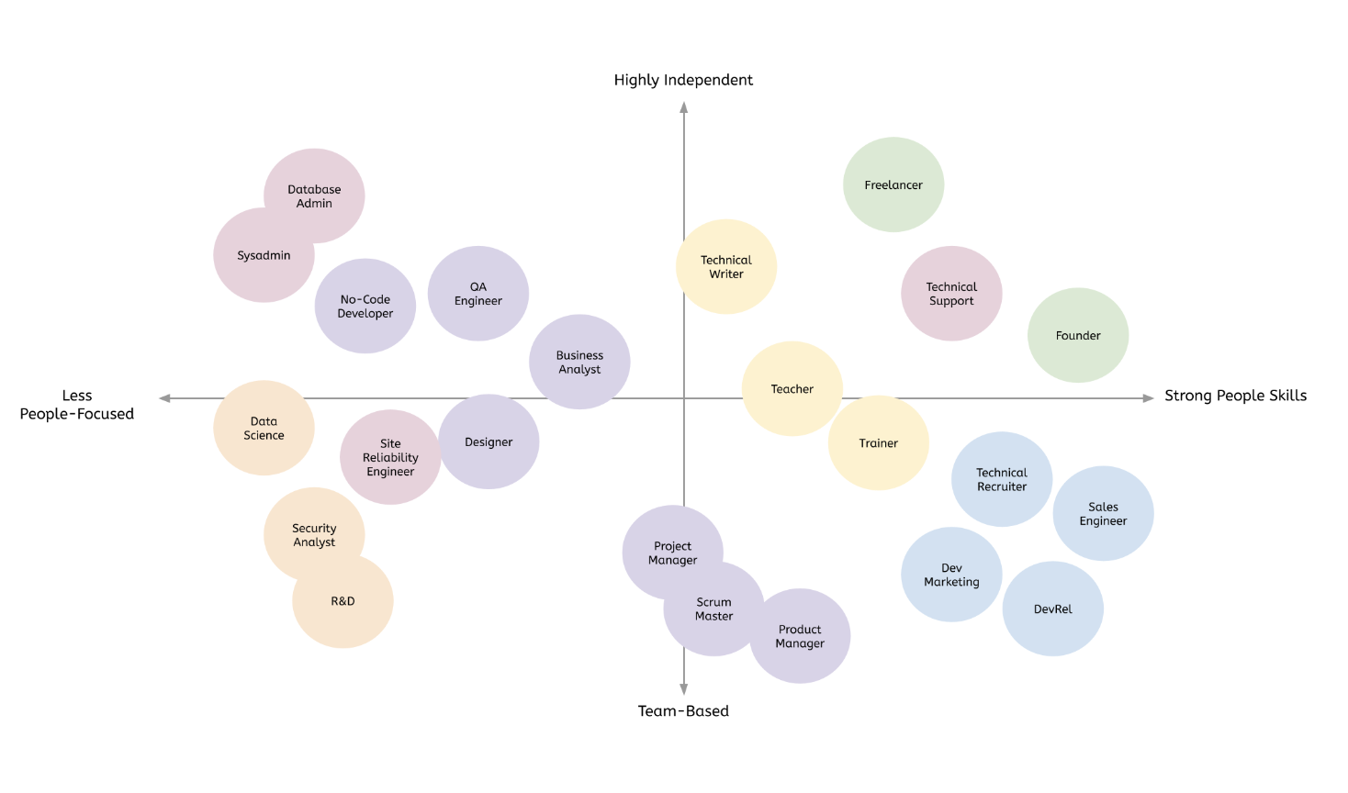

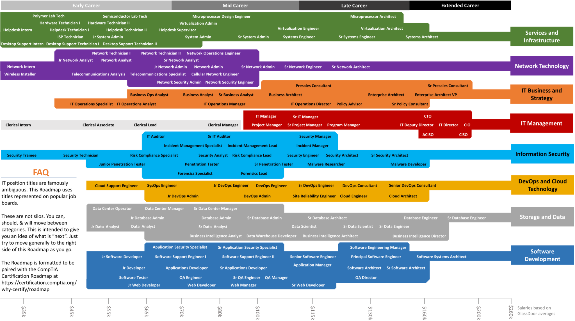

**SOFTWARE PATHWAYS**

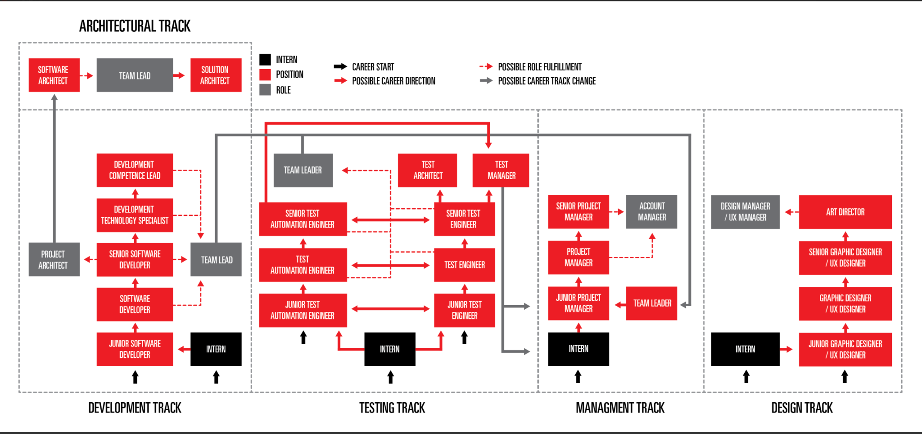

**TECHNOLOGY (IT) PATHWAYS**

